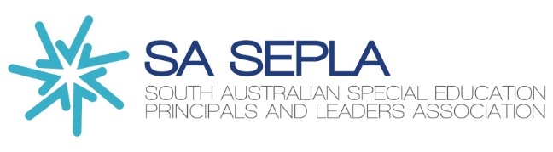
2026 SA SEPLA Awards
Nomination Form

The 2026 SA SEPLA awards are a great opportunity for leaders to acknowledge the great work they witness every day. It is an opportunity for great practitioners to have their story heard by their professional peers. To nominate a person for a SA SEPLA award is a simple and short process. The feedback from past winners demonstrates a need to keep the awards going. Please fill in the nomination form below.

Please be prompt as we would like to announce these amazing educators and support people at our term 4 Conference.

Name of nominee/project and site: Click or tap here to enter text.

Email address of nominee: Click or tap here to enter text.

Name of person completing the nomination: Click or tap here to enter text.

Please select the box identifying the award – You may nominate as many awards as you like.

☐ Experienced Teacher Award (teachers with 5 years or more experience)

☐ Early Career Teacher (teachers in their first 4 years)

☐ Best practice/project award

☐ Ancillary award

☐ Volunteer award

☐ Non-school-based support person/group award

Please write an example as to how the nominee has demonstrated influence through innovation and change, in line with SASEPLA values, to improve student outcomes. 200-word limit.

Click or tap here to enter text.

Closing date for the applications is 5:00pm on Monday 14th September 2026
Please send to Heike Harris
Heike.Harris244@schools.sa.edu.au

